**Lab Assignment – 1**

1. Create ASP.NET page to accept a name from the user and display welcome message.

**Demo.aspx Code**

<%@ Page Language="C#" AutoEventWireup="true" CodeBehind="Assignment1_.Q1.aspx.cs" Inherits="_6_ASP.NET.Assignment1__Q1" %>

<!DOCTYPE html>

<html xmlns="http://www.w3.org/1999/xhtml">

<head runat="server">

<title></title>

</head>

<body>

<form id="form1" runat="server">

<div>

</div>

<p>

&nbsp;&nbsp;&nbsp;&nbsp;&nbsp;&nbsp;&nbsp;&nbsp;&nbsp;&nbsp;&nbsp;

<asp:Label ID="Label1" runat="server" ForeColor="#FF3300" Text="Enter Name"></asp:Label>

<asp:TextBox ID="TextBox1" runat="server" BackColor="#00FFCC" OnTextChanged="TextBox1_TextChanged" style="margin-left: 27px"></asp:TextBox>

</p>

<p>

<asp:Button ID="Button1" runat="server" BackColor="Lime" OnClick="Button1_Click" style="margin-left: 112px" Text="Submit" />

</p>

<p>

&nbsp;&nbsp;&nbsp;&nbsp;&nbsp;&nbsp;&nbsp;&nbsp;&nbsp;&nbsp;&nbsp;&nbsp;&nbsp;&nbsp;&nbsp;&nbsp;&nbsp;&nbsp;&nbsp;&nbsp;&nbsp;&nbsp;&nbsp;&nbsp;

<asp:Label ID="Label2" runat="server" Text="Label"></asp:Label>

</p>

</form>

</body>

</html>

**Demo.aspx.cs Code**

using System;

using System.Collections.Generic;

using System.Linq;

using System.Web;

using System.Web.UI;

using System.Web.UI.WebControls;

using System.Xml.Linq;

using static System.Net.Mime.MediaTypeNames;

namespace _6_ASP.NET

{

public partial class Assignment1__Q1 : System.Web.UI.Page

{

protected void Page_Load(object sender, EventArgs e)

{

}

protected void TextBox1_TextChanged(object sender, EventArgs e)

{

}

protected void Button1_Click(object sender, EventArgs e)

{

string name = TextBox1.Text.Trim();

if (!string.IsNullOrEmpty(name))

{

Label2.Text = $"Welcome, {name}!";

}

else

{

Label2.Text = "Please enter your name.";

}

}

}

}

**Output Screenshot:**

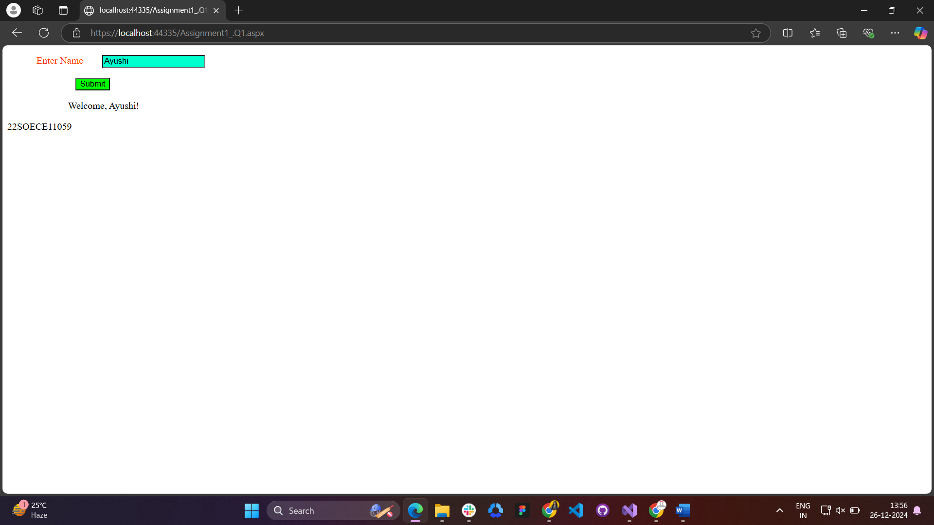**2. 2.** Create ASP.NET page to generate the Temperature Conversion.

**Demo.aspx Code**

<%@ Page Language="C#" AutoEventWireup="true" CodeBehind="Assignment1_Q2.aspx.cs" Inherits="_6_ASP.NET.Assignment1_Q2" %>

<!DOCTYPE html>

<html xmlns="http://www.w3.org/1999/xhtml">

<head runat="server">

<title></title>

</head>

<body>

<form id="form1" runat="server">

<div>

&nbsp;&nbsp;&nbsp;&nbsp;&nbsp;&nbsp;&nbsp;&nbsp;&nbsp;&nbsp;&nbsp;&nbsp;&nbsp;&nbsp;&nbsp;&nbsp;&nbsp;&nbsp;

<asp:Label ID="Label1" runat="server" Text="Add temperature"></asp:Label>

<asp:TextBox ID="TextBox1" runat="server" OnTextChanged="TextBox1_TextChanged" style="margin-left: 30px"></asp:TextBox>

</div>

<p>

&nbsp;&nbsp;&nbsp;&nbsp;&nbsp;&nbsp;&nbsp;&nbsp;&nbsp;&nbsp;&nbsp;&nbsp;&nbsp;&nbsp;&nbsp;&nbsp;&nbsp;&nbsp;

</p>

<p>

&nbsp;&nbsp;&nbsp;&nbsp;&nbsp;&nbsp;&nbsp;&nbsp;&nbsp;&nbsp;&nbsp;&nbsp;&nbsp;&nbsp;&nbsp;&nbsp;&nbsp;&nbsp;&nbsp;&nbsp;&nbsp;&nbsp;&nbsp;&nbsp;&nbsp;&nbsp;&nbsp;

<asp:Button ID="Button1" runat="server" OnClick="Button1_Click" Text="Get Fehrenhit" />

</p>

<p>

&nbsp;</p>

</form>

</body>

</html>

**Demo.aspx.cs Code**

using System;

using System.Collections.Generic;

using System.Linq;

using System.Web;

using System.Web.UI;

using System.Web.UI.WebControls;

namespace _6_ASP.NET

{

public partial class Assignment1_Q2 : System.Web.UI.Page

{

protected void Page_Load(object sender, EventArgs e)

{

}

protected void Button1_Click(object sender, EventArgs e)

{

int n1;

n1 = Convert.ToInt32(TextBox1.Text);

double Button1 = ( n1 * 9/5 ) + 32;

Response.Write("Temperature in Fahrenheit is " + Button1);

}

protected void TextBox1_TextChanged(object sender, EventArgs e)

{

}

}

};  
Output :

